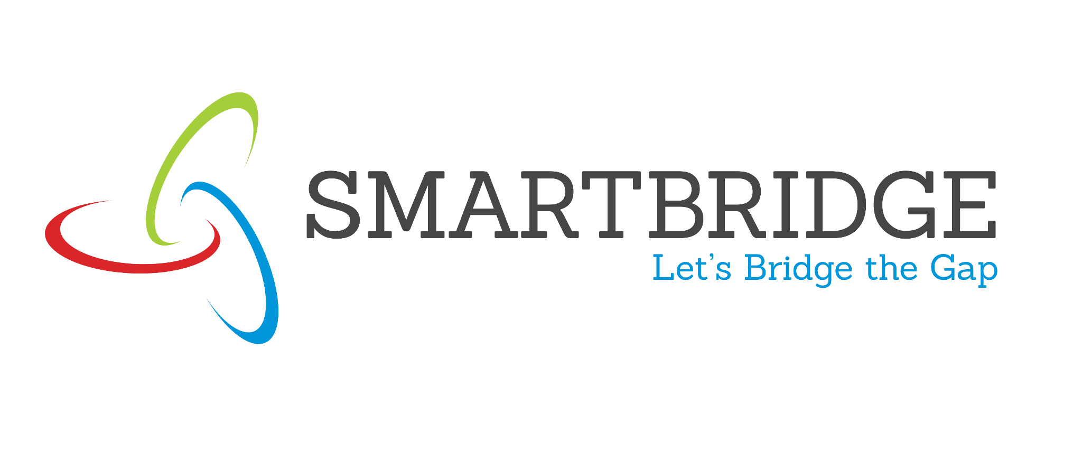 | 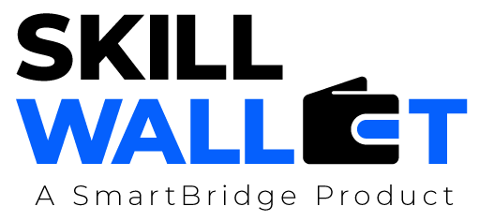
PROCUREMENTIQ AI — Autonomous Procurement Risk & Negotiation Intelligence
Procurement | Enterprise Operations | Supply Chain · Project Abstract
Assignee | Assigned By | Assigned On
Ashok | Tharuna | 19/10/2026
PROJECT DESCRIPTION
Procurement teams must compare suppliers, analyze quotations, assess delivery risks, and select vendors without overlooking hidden costs or contractual risks. This project develops PROCUREMENTIQ AI, a procurement intelligence platform that evaluates quotations, checks supplier reliability, models costs, and produces explainable vendor recommendations. Six specialized agents work together: they parse requirements into structured criteria, extract quotation details, research suppliers from approved sources, assess risks, compare total cost, and produce a ranked shortlist. A key differentiator is a transparent decision model that keeps measurable cost calculations separate from AI-generated explanations, so every recommendation can be traced back to its evidence.
PROJECT SCENARIO
Three suppliers offer the same equipment at different prices, and the lowest price may not be the best choice. PROCUREMENTIQ AI parses the purchase requirement into structured criteria, extracts the details of each quotation, and gathers supplier information from approved sources. It then compares purchase price, shipping, warranty, delivery timelines, and risk indicators before producing its recommendation. The result is a ranked shortlist with evidence and trade-offs, giving the procurement team a clear, explainable basis for selecting a vendor.
KEY FUNCTIONS & MODULAR COMPONENTS
Requirement Parser Agent  Converts purchase requirements into structured evaluation criteria. | Quote Analyzer Agent  Extracts prices, quantities, terms, and delivery commitments from supplier quotations.
Supplier Researcher Agent  Retrieves supplier information from approved sources. | Risk Assessor Agent  Evaluates delivery, concentration, compliance, and dependency risks for each supplier.
Cost Optimizer Agent  Compares the total cost of each offer, not just the purchase price. | Procurement Advisor Agent  Produces a ranked shortlist of vendors with supporting evidence and trade-offs.
TOOLS & TECHNOLOGIES
Agent Orchestration  LangGraph | LLM Backend  LLM API (explanations) | Backend  Python + FastAPI
Document Processing  OCR / PDF Parsing | Optimization & Analytics  Pandas / NumPy / SciPy | Enterprise Integrations  Supplier / ERP APIs

